

TABLEAU

INTERNSHIP PROJECT



**DATA ANALYSIS USING TABLEAU**

INTERNSHIP PROJECT REPORT

**by**

**PRIYANKA SUNKARA**

23KQ5A0505

Department of Computer Science and Engineering

PACE Institute of Science and Technology

Vallur

June 2024

## BONAFIDE CERTIFICATE

This is to certify that this project report entitled **“DATA ANALYSIS USING**

**TABLEAU”** submitted to **PACE Institute of Science and Technology, Vallur**

is a bonafied record of work done by **“PRIYANKA SUNKARA”** under my

supervision from **“20-05-2024”** to **“11-06-2024”**

<<Signature of the Supervisor>>

<<Name and Designation>>

<<Countersignature>>

<<Name>>

<<Designation, eg. Head of Dep. / Divisional Head)

<<Name of Department / Division and Centre>>

**Declaration**

This is to declare that this report has been written by Priyanka Sunkara. No part of the report is plagiarized from other sources. All information included from other sources have been duly acknowledged. I aver that if any part of the report is found to be plagiarized, I shall take full responsibility for it.

PRIYANKA SUNKARA

23KQ5A0505

**ABSTRACT**

This project addresses the challenge of effectively analyzing retail data from the Sample Superstore dataset to gain insights into sales, profit, and quantity metrics across various dimensions. Traditional data analysis methods often lack the capability to provide a comprehensive and interactive exploration of these metrics.

The significance of this project lies in its utilization of Tableau to create an interactive dashboard, enabling stakeholders to dynamically analyze sales, profit, and quantity across category, sub-category, ship mode, segment, and state dimensions. This approach is novel in its integration of multiple interactive features, such as dynamic filters and highlight actions, providing a user-friendly interface for detailed data analysis.

The approach involved connecting to the Sample Superstore dataset, preparing the data, and constructing a series of interconnected visualizations. These visualizations include sales analysis, profit analysis, and quantity analysis across the specified dimensions. Interactive filters and parameters were incorporated to allow users to customize their views, enhancing the data exploration experience.

The major results obtained include the identification of sales trends and profit margins across different categories and sub-categories, insights into the impact of ship modes and customer segments on sales and profitability, and a detailed analysis of sales and profit distribution across various states. These insights are crucial for strategic decision-making and identifying areas for growth and optimization.

In conclusion, the interactive dashboard created in Tableau serves as a powerful tool for transforming raw retail data into meaningful visual insights. It facilitates better decision-making and strategic planning, showcasing the value of advanced data visualization techniques in the retail industry. This project highlights the importance of interactive and user-friendly data analysis tools in enhancing business intelligence and operational efficiency.

## TABLE OF CONTENTS

**CHAPTER NO. TITLE PAGE**

**ABSTRACT**

**CONTENTS**

1. **Introduction to Tableau 1**
2. **Features of Tableau 2**
3. **Tableau Products 3**
4. **Advantages and Disadvantages of Tableau Public 5**
5. **Installation of Tableau Public 6**
6. **Tableau Public Interface 8**
7. **Connections 9**
8. **Types of Connections 9**
9. **How to import data source 10**
10. **Data Types 10**
11. **Data Interpreter 11**
12. **Worksheet 11**
13. **Charts 11**
14. **Types of Charts 12**
15. **Set 19**
16. **Combined Set 19**
17. **Group 19**
18. **Difference between Set and Group 19**
19. **Parameters 20**
20. **Calculation Field 20**
21. **Filters 20**
22. **Types of Filters 20**
23. **Filtering Order of Operations 23**
24. **Operators 23**
25. **Types of Operators 23**
26. **Functions 25**
27. **Types of Functions 25**
28. **Sorting 33**
29. **Reference Line 33**
30. **Forecast 34**
31. **Trend Line 34**
32. **Calculations 35**
33. **Types of Calculations 35**
34. **Relationships 36**
35. **Joins 36**
36. **Types of Joins 37**
37. **Cross Database Joins 43**
38. **Unions 44**
39. **Blending 45**
40. **Dashboard 45**
41. **Story 47**
42. **Mini Projects** 
    1. **Netflix Insights Dashboard 51**
    2. **HR Insights Dashboard 52**
    3. **Wine Sales Insights Dashboard 53**
    4. **Super Store Data Insights Dashboard 54**
43. **Main Project**
    1. **Super Store Interactive Dashboard 54**

* Data Interpreter
* Pivot
* Dimension & Measure
* Data Types
* Discrete & Continuous field
* Geographic Locations
* Tableau Connections
* Charts
* Granularity & Aggregation
* Groups & Sets
* Filters
* Parameter
* Quick Filters
* Hierarchy
* Tree Map & Dual Axis
* Joins
* Union
* Blend
* Calculated Field
* Table Calculations
* Addressing and Partitioning
* LOD expressions
* Tooltip
* Reference Line
* Control Reference Line with Parameters
* Data mining
* Trend Lines
* Geographic visualization
* Dashboards
* The Dashboard Interface
* Dashboard Objects
* Building a Dashboard
* Story Points

## What is tableau?

Tableau is the Fastly growing and powerful data visualization tool. Tableau is a business intelligence tool which helps us to analyse the raw data in the form of the visual manner; it may be a graph, report, etc.

**Example:** - If you have any data like **Big Data, Hadoop, SQL,** or any cloud data and if you want to analyse that given data in the form of pictorial representation of data, you can use Tableau.

Data analysis is very fast with Tableau, and the visualizations created are in the form of worksheets and dashboards. Any professional can understand the data created using Tableau.

## Tableau Public

* Tableau Public is a free and open-source.
* Tableau public data source can connect to Excel and Text files.
* Tableau public can be installed on Window and Mac operating system.
* Data and Visualizations are not secured in the Tableau public because it is available in public.
* In Tableau public, data cannot be obtained from different data sources as it is limited to connect only Excel and Text files.
* Tableau public uses the details at Personal level.

## Why use Tableau?

Here are some reasons to use Tableau:

* Ultimate skill for Data Science
* User-Friendly
* Apply to any Business
* Fast and Easy
* You does not need to do any Coding
* Community is Huge
* Hold the power of data
* It makes it easier to understand and explain the Data Reports

**Types of tableau connections?**

* Live and Extract are two ways you can make the data connection to the tableau. Live allows you real-time data while extracts are a kind of batch which needs to be refreshed from time to time to get the updated data.

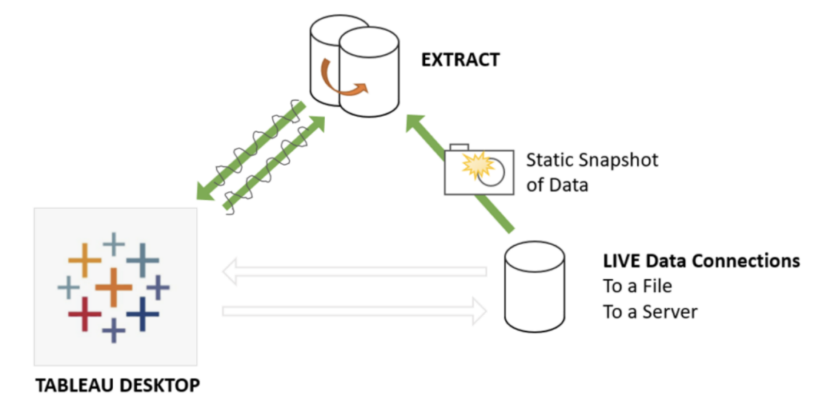

**What does a data interpreter do?**

* Data Interpreter can give you a head start when cleaning your data. It can detect things like titles, notes, footers, empty cells, and so on and bypass them to identify the actual fields and values in your data set.
* Use the Data Interpreter check box to see if Data Interpreter can help clean up your data.

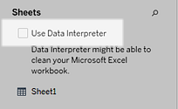

* In the Data pane, click the **Review the results** link to review the results of the Data Interpreter.

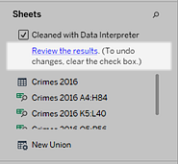

**What is a Pivot?**

* Transform your data from columns to rows.

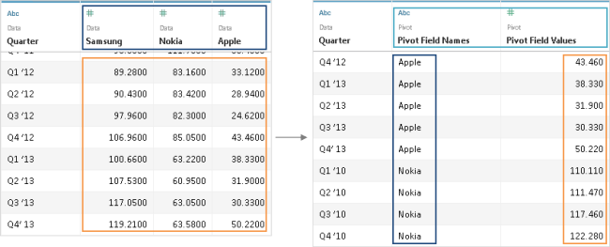

* Select two or more columns. Click the drop-down arrow next to the column name, and then select Pivot.

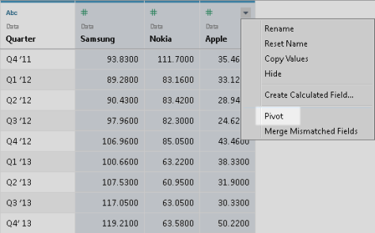

**What are Dimension and Measure in Tableau?**

* **Dimension:** A categorical variable from the dataset that is used to slice and dice the data into different categories. Dimensions are often discrete data. Examples include country, gender, student ID, and name. When a dimension is pulled into your sheet, it takes the form of a blue pill.
* **Measure:** A variable from the dataset that is meant to be aggregated. (This means it should be a number that makes sense to do math with: sum, average, and so on.) Measures are often continuous data. Examples include GPA, sales, quantity, quota, height, and salary. When a measure is pulled into your sheet, it takes the form of a green pill.

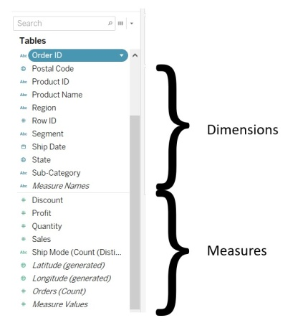

## Tableau Basic Filters

* A filter is used to limit what data is being displayed on the sheet. Visible controls for a filter on a sheet or dashboard are called Quick Filters. Each filter is for an individual data field. Both dimensions and measures can be used as filters.
* The way to create a filter is to drag a field directly from the Data pane to the Filters shelf.



* When you add a field to the Filters shelf, the **Filter dialog box opens so you can define the filter.** The Filter dialog box differs depending on whether you are filtering categorical data (dimensions), quantitative data (measures), or date fields.

## Advantages of Tableau

## Advantage of tableau

## Disadvantages of Tableau

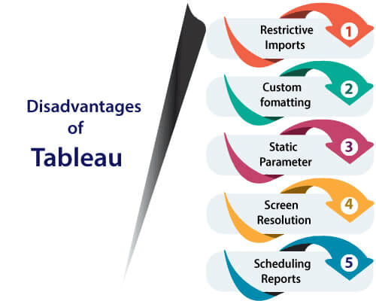

## The Most commonly used Tableau terminologies are listed below:

1. **Alias:** Alias is an alternative that you can assign to a dimension member, to a measurement part or a field.
2. **Bin:** Bin is a user-defined group of measures in the data source.
3. **Bookmark:** A document in the bookmarks folder in the Tableau repository that contains a single worksheet. It helps in improving data analysis. Unlike, web browser bookmarks, files are a compatible way to display various studies quickly.
4. **Calculated field:** Calculated field is a new field that the user creates derived files by using a formula to modify the existing fields in your data source. It is used to make your work simple and easy.
5. **Crosstab:** Crosstab is used for a text table view. It uses various text tables to display the numbers associated with dimension members.
6. **Dashboard:** The dashboard is a combination of several views that are arranged on a single page. In Tableau, dashboards are used to observe and compare a variety of data together, and also it allows interacting with other worksheets.
7. **Data Pane:** The data pane is on the left side of the workbook displays the fields of the data sources to which Tableau is connected. The fields are further divided into measures and dimensions. The data pane also reflects custom fields such as groups, binned fields, calculations, and many more. You can build views of your data by dragging fields from the data pane onto the various shelves, which is a part of every worksheet.
8. **Data Source Page:** Data Source is a page where you can set up your data source. This data source page generally consists of four main areas? join area, left pane, a preview area, and metadata area.
9. **Dimension:** Dimension is commonly known as a field of categorical data. Dimensions hold discrete data such as members and hierarchies that cannot be aggregated. It also contains characteristic values such as dates, names, and geographical data. The dimensions used to reveal details of your information.
10. **Extract:** An extract is a saved subset of a data source which is used to improve performance and study offline. The users can create an extract by defining limits and filters that contain the data which you want in the extract.
11. **Filters Shelf:** Filter shelf is located on the left side of the workbook. Filters shelf is used to exclude the data from a view by filtering it using both dimensions and measures.
12. **Format Pane:** The Format pane is on the left side of the workbook, and it contains various formatting settings. It controls the entire view of the worksheet, as well as the individual fields in the view.
13. **Level of Detail expression (LOD):** The level of detail Expression is a syntax that supports the combination of various dimensions other than the view level. With the help of detail expressions, one can attach multiple dimensions with an aggregate expression.
14. **Marks:** Marks is a part of the view that visually represents one or more rows in a data source. It can be a line, square, or bar. You can control and alter the size, type and colour of marks.
15. **Marks Card:** Marks card is on the left side of the worksheet. The user can drag fields to the control mark properties such as colour type, shape, size, label, detail, and tooltip.
16. **Pages Shelf:** Page shelf is on the left side of the view. With the help of the page shelf, you can split a view into a sequence of pages based on the values and members in a continuous or discrete field. Adding a field with the pages shelf is similar to adding a field in rows shelf. For each new row, a new page is created.
17. **Rows shelf:** Row shelf is on the top of the workbook. It is used to create the rows of a data table. The Row shelf provides any numbers of measures and dimensions. When you placed a dimension on the Rows shelf, then Tableau creates headers for the members of that dimension. And when you place a measure on the Rows shelf, Tableau creates quantitative axes for that particular measure.
18. **Shelves:** The shelves are named areas that are located on the top and left of the view. You can build views by placing fields onto the shelves. Some shelves are only available when you select a particular mark type. For example, The Shape shelf is only open when you choose the specific Shape mark type.
19. **Workbook:** A workbook is a file with extension that holds one or more worksheets as well as dashboards and stories.
20. **Worksheet:** The worksheet is a collection of sheets. It's place where you build views of your data by dragging various fields onto the shelves.

## Data Types in Tableau

## 

Tableau expresses fields and assigns data types automatically. If the data source appoints the data type, Tableau will use that data type. If the data source doesn't individually assign a data type, Tableau will assign one. Tableau consist of the following data types:

* Date values
* Text values
* Numerical values
* Date and time values
* Boolean values (True or False conditions)
* Geographic values (longitude and latitude used for maps)

**Discrete and continuous data field?**

* Continuous means "forming an unbroken whole, without interruption"; discrete means "individually separate and distinct."

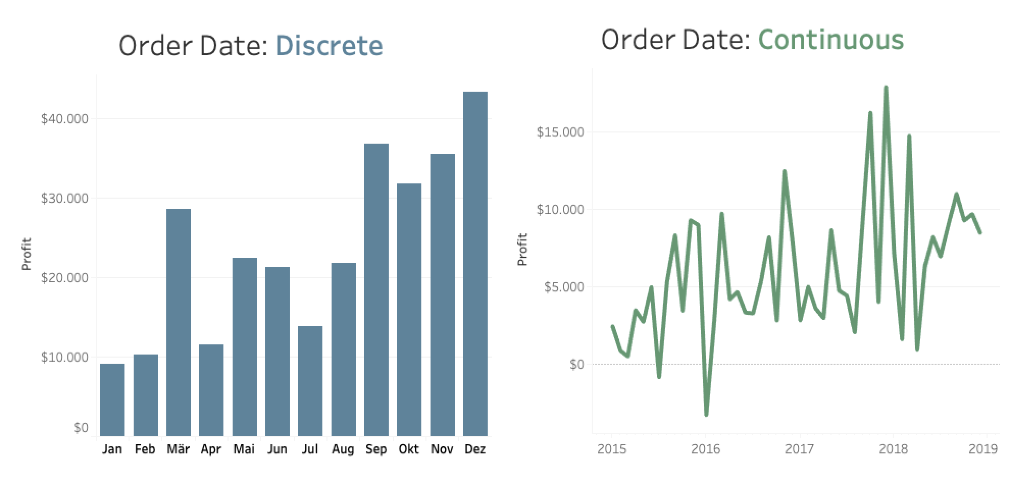

**How to assign a geographic role to a geographic data field**

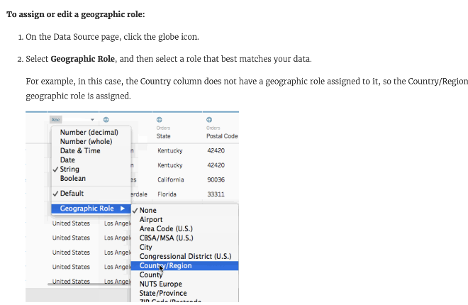

**What is data granularity?**

* Data granularity is a **measure of the level of detail in a data structure**.
* In **time-series data**, for example, the **granularity** of measurement might be based on **intervals of years, months, weeks, days, or hours**.

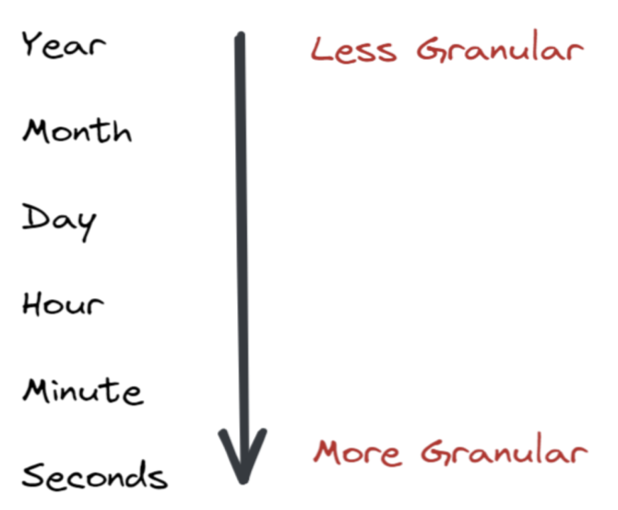

## Data Aggregation in Tableau

It is useful to look at numeric values using different aggregation function. Tableau supports many different aggregation types, such as:

* Sum
* Average
* Count
* Count Distinct
* Median
* Minimum
* Maximum
* Variance
* Variance of Population
* Standard Deviation
* Standard Deviation of Population
* Attribute
* Dimension

## Aggregating Dimensions

You can aggregate dimension in the view as **Maximum**, **Minimum**, **Count**, and **Count Distinct**. When you aggregate a dimension, you have to create a new temporary measure column, so the dimension takes on the characteristics of a measure

**What is the relationship between granularity and aggregation?**

* Granularity and aggregation work opposite of each other.
* In Tableau, when you bring dimensions and measure to the view, the measures are aggregated by whatever dimensions are on the view.
* As you remove and add more dimensions you are decreasing and increasing the granularity. The more dimensions/details on the view, the more granular it is.

## Data Connection with Microsoft Excel

Step1**:** Click on the **Microsoft Excel** option given in the data tab.

Step2: In the next screen,

1. Select the Microsoft Excel file you want to connect such as **sample-superstore.xls**.
2. Click on **open** option.

Step3: It connects the Microsoft Excel file to Tableau. The sheets present in the Microsoft Excel file are shown on the left-hand side of the window.

Step4: You can drag one or more sheets from the sheets data tab such as **Orders**.

## Tableau Data Joining

Data joining is a common requirement in any data analysis. You may need to join data from different tables in a single source or join data from multiple sources.

A join means combining columns from one or more tables in a relational database.

## ****Joins are Specifies into five types****

1. Cross Join.
2. Inner Join.
3. Natural Join.
4. Outer Join
   * Left Outer Join.
   * Right Outer Join.
   * Full Outer Join.
5. Self-Join

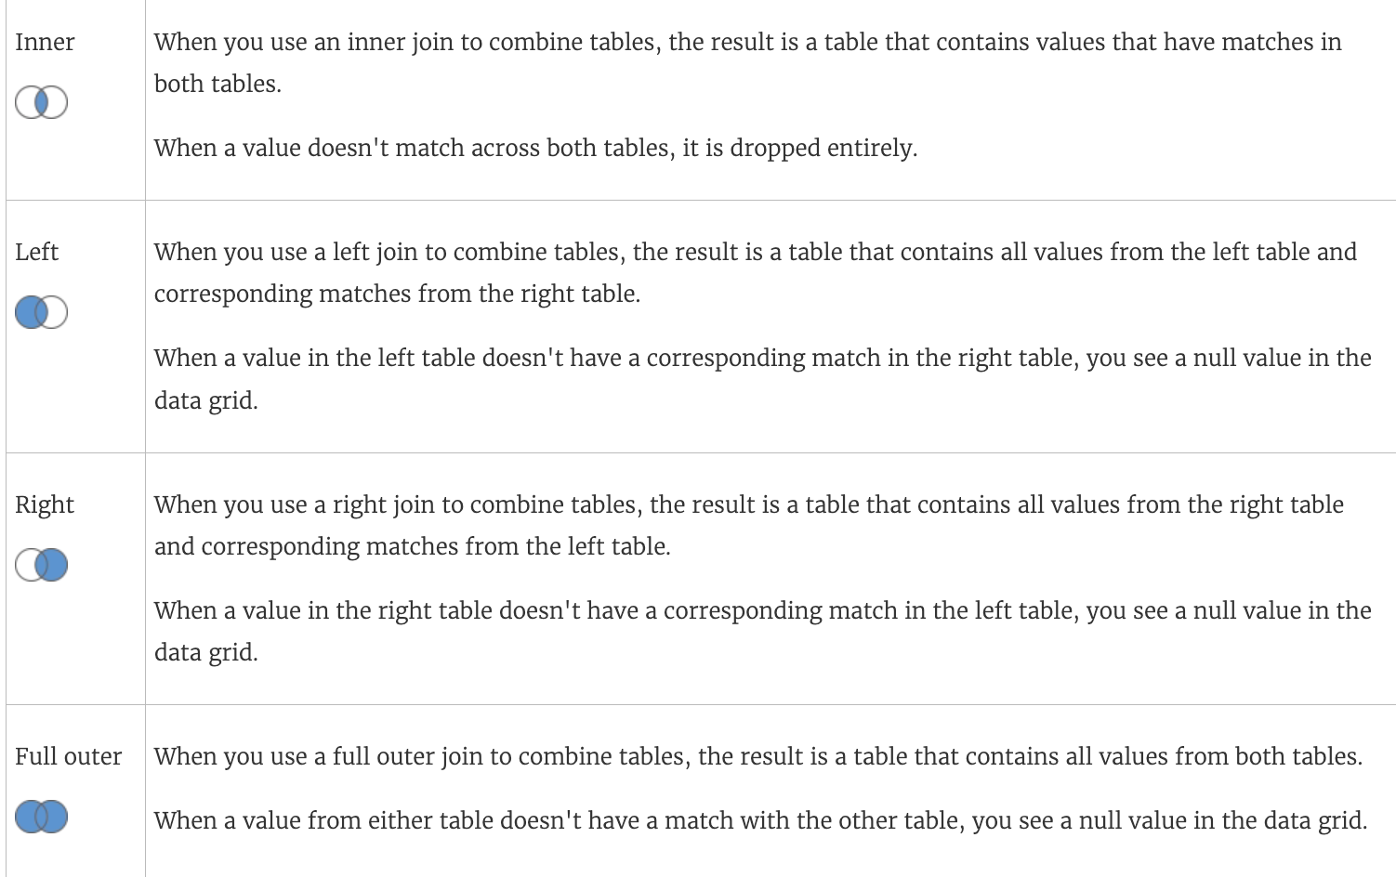



## Overview of Types of Joins

A join section is used to combine rows from two or more tables, based on a related column between them.

* **Cross Join:** Cross join produces rows which combine each row from the first table with each row from the second table.
* **Inner Join:** An inner join returns the matching rows from the tables that are being join
* **Natural Join:** Natural join is not used any comparison operator. It does not concatenate the way
* **Outer Join:** An outer join is an extended form of the inner join
* **Left Outer Join:** The left outer join returns matching rows from the tables being joined and non-matching rows from the left table in the result and places **NULL** values in the attributes that come from the right table
* **Right Outer Join:** The right outer join operation returns matching rows from the tables being joined and non-matching rows from the right table in the result and places **NULL** values in the attributes that come from the left table.
* **Full Outer Join:** The full outer join is used to combine tables. As a result, it contains all values from both tables.

When a value from a table does not have a match with the other table, then it returns a **NULL** value in the data grid.

* **Self-Join:** The self-join is used to join a table with itself. It means that each row of the table is combined with itself as well as with every other row of the table.

## Data Blending in Tableau

Data Blending is a powerful feature of Tableau. It is used to analyze the data in a single view from a related data in multiple data source.

**For example:** Suppose a Sales data is present in a relational database and Sales Target data in an Excel sheet.



## Tableau Data Sorting

Once the data is a connected with Tableau, data sorting is done using the **Sort Fields** option. The **Sort Fields** option is present in the **Data Source** tab.

There are two ways to sort the data in Tableau:

1. **Manual sorting:** Manual sorting is a sort that rearranges the order of dimension fields by dragging them next to each other in **ad hoc** fashion.
2. **Computed sorting:** The computed sorting is a sort which is directly applied on the axis using the sort dialog button.

## Sort from an Axis

* Float over a numerical axis to get the sort icon.
* Click that icon to sort.

## Sort from a Header

* Float over a header to get the sort icon.
* Click that icon to sort.

## Tableau Calculation

There are four necessary components to the calculation in Tableau:

1. **Function:** Function statements are used to transform the values or members in a field.
2. **Fields:** Field is dimensions and measures from your data source.
3. **Operators:** Operator is a symbol that denotes an operation between the operands.

**4.Literal Expression:** Literals expression are represent the constant values.  
 **For Example:** See the below calculation

**IF [Profit per Day] > 5000THEN"Highly Profitable"**

**ELSEIF [Profit per Day] <= 0THEN"Unprofitable"**

**ELSE "Profitable"**

**END**

**5.Parameters:** Parameter is a placeholder variable that can be inserted into calculation replace the constant values.

A parameter in a calculation is surrounded by brackets [ ]

SUM ([Sales]) / SUM ([Profit])

## Tableau LOD Expressions

LOD (level of Details) expression is used to run complex queries involving many dimensions at the data sources instead of bringing all the data to the Tableau interface.

## Types of LOD expression

* **FIXED LOD:** This LOD expression computes the values using the specified dimensions without reference to any other dimensions in the view.
* **INCLUDE LOD:** This LOD expression computes the values using the specified dimensions with any other dimensions in the view.
* **EXCLUDE LOD:** These LOD expressions subtract dimensions from the view level of detail.
  + - {FIXED [Region]: SUM([Sales])}
    - So calculated field named **SalesByRegion** having f**ixed LOD** is now placed on the text under marks

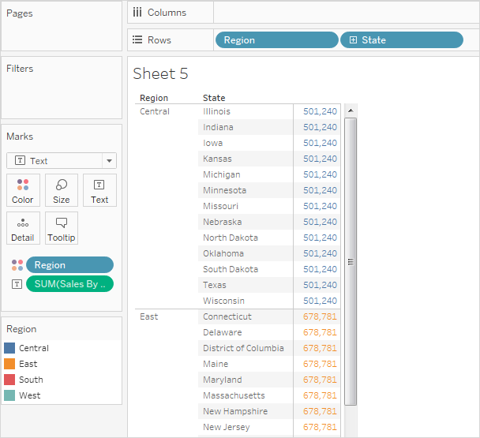

## Tableau Basic Filters

Filtering is the process of removing specific values from a result set. Tableau filtering feature allows both simple scenarios using field values and advanced calculation or context-based filters.

## In Tableau, there are three types of basic filters as follows:

* **Filters Dimensions:** Filter dimensions are the filters applied to the dimension fields.
* **Filters Measures:** Filter measures are the filters applied to the measure fields.
* **Filter Dates:** Filter dates are the filters applied on the date fields.

## Creating Filters

* Filters are designed by dragging the required field to the Filters shelf.
* Then, create a horizontal bar chart by dragging the dimension (**Sub-Category**) to the Rows shelf and the measure (**sales**) to the Columns shelf.
* Again, drag the **Sales** into the Filters shelf, select **sum** option among all options, and click on the **Next** button.
* Once this filter is created, right-click and choose the **Edit Filter** option from the pop-up menu.
* Select one option among these options and click on **OK** button to apply the filter

## Create Filters for Measures

Measures are numeric fields. So, the filter options for such fields involve choosing values. There are following types of filters for measures in Tableau:

* **Range of values:** It specifies the minimum and maximum values of the range to include in the view.
* **At Least:** It includes all values that are greater than or equal to a specified minimum value.
* **At Most:** It includes all values that are less than or equal to a specified maximum value.
* **Special:** It helps you filter on Null values. It includes Null values, Non-null values, or All Values.

## Create Filters for Dimensions

Dimensions are descriptive fields having string values. There are following types of filters for dimensions in Tableau:

* **General Filter:** It allows to select specific values from a list.
* **Wildcard Filter:** It allows to mention wildcards like **cha\*** to filter all string values starting with **cha**.
* **Condition Filter:** It applies conditions such as sum of sales.
* **Top Filter:** It chooses the records representing a range of high values.

## Create a Context Filter

To create a context filter, first select **Add to Context** from the context menu of an existing categorical filter. The context is computed once the view is generated. All other filters are then calculated relative to the context. Context filters are:

**Step1:** Drag the **Sub-Category** field to the Rows shelf and Sales field to the Columns Shelf.

**Step2:** And, choose the horizontal bar chart from the "**Show Me**" tab.

**Step3:** Again, drag the **Sub-Category** to the Filters shelf.

**Step4:** Right-click on the **Sub-Category** field in the filter shelf and click on "**Edit Filter** " option then go the " **Top** " tab in the pop-up window.

**Step5:** And, choose the "**By field** " option. From the next drop-down, choose the option Top 10 by Sales Sum.

**Step6:** Drag the **Category** field to the filter shelf. Right-click on the Category field to edit and choose **Furniture** from the list. It shows three subcategories of products as a result.

**Step7:** Now, adding the context filter, Right-click on the **Category: Furniture** filter and select the "**Add to Context**" option.

**Groups in Tableau**

**Tableau** allows **single-dimensional members to be grouped together** and automatically **creates a new dimension** with the Tableau Group at the end of the name.

* In the Data pane, right-click a field and select Create > Group.

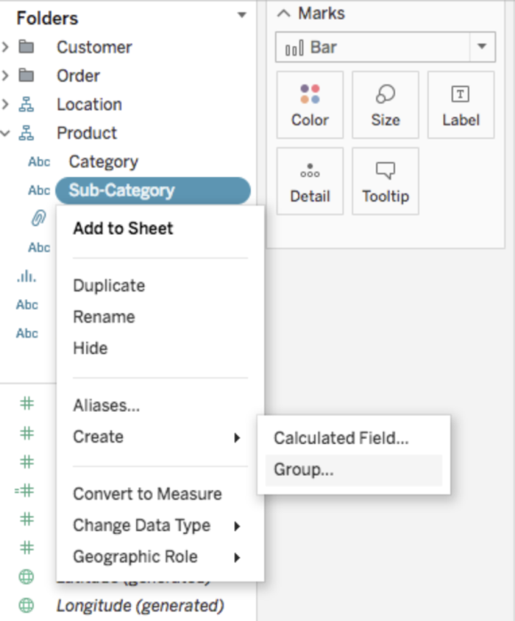

* In the Create Group dialog box, select several members that you want to group, and then click **Group**.

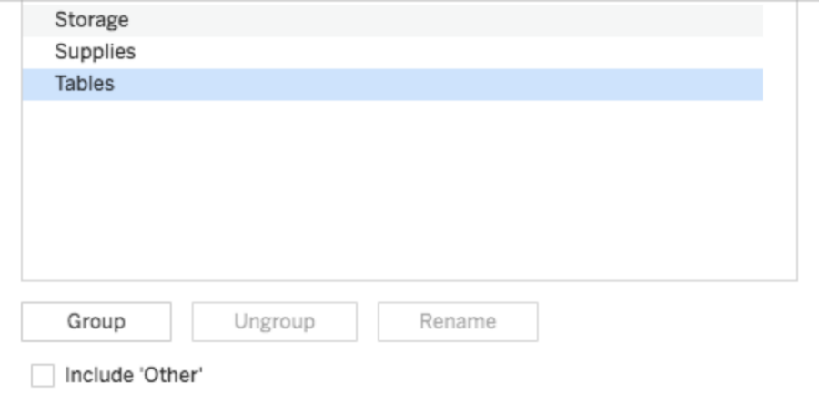

## Tableau Build Groups

**Step1:** Right click on the **Category** field.

**Step2:** Click on the "**Create**" option.

**Step3:** Then, select "**Group**" option

**Step4:** It opens the "**Create Group**" window. Then,

1. Write the name of the group.
2. Select the members which you want to be grouped.
3. Click on the "**Group**" button.

**Step5:** In "**Edit Group**" window,

1. It creates a group of **Furniture** and **Office Supplies**.
2. Then, click on the **OK** button to create the group.

**What are hierarchies in tableau?**

* Often data sources have related dimensions that have an inherent hierarchy. For example, a data source may have fields for Country, State, and City. These fields could be grouped into a hierarchy called Location. In this example, a user can expand the country and break down the data by state and city.



## Tableau Build Hierarchy

In Tableau, Hierarchies can be built to visualize the data. It can be created in the Tableau by following the below steps:

**For example**, consider the data source such as **Sample-Superstore** and its dimensions and measures.

**Step1:** First go to the worksheet. Then,

1. Select a dimension and right-click on that dimension to create a hierarchy.
2. Go to "**Hierarchy**" option.
3. And, click on the "**Create Hierarchy**" option.

**Step2:** It opens the "**Create Hierarchy?**" window. Then

1. Enter a name of hierarchy.
2. And click on the **OK** button.

## To Remove a Hierarchy

From the data pane, you can remove the inbuilt hierarchy as well. Here are the following steps to remove the hierarchy.

**Step1:** Select the hierarchy which you want to remove.

**Step2:** Right-click on that hierarchy.

**Step3:** And select the "**Remove Hierarchy**" option

## Tableau Bar Chart

In Tableau, there are various types of bar chart that can be created by using the dimensions and measures.

A bar chart represents the data in rectangular bars. Tableau automatically produces a bar chart when you drag a dimension to the Row shelf and measure to the Column shelf.

The bar chart option present in the **"Show Me"** button. If the data is not appropriate for the bar chart, then this option will be automatically blocked out.

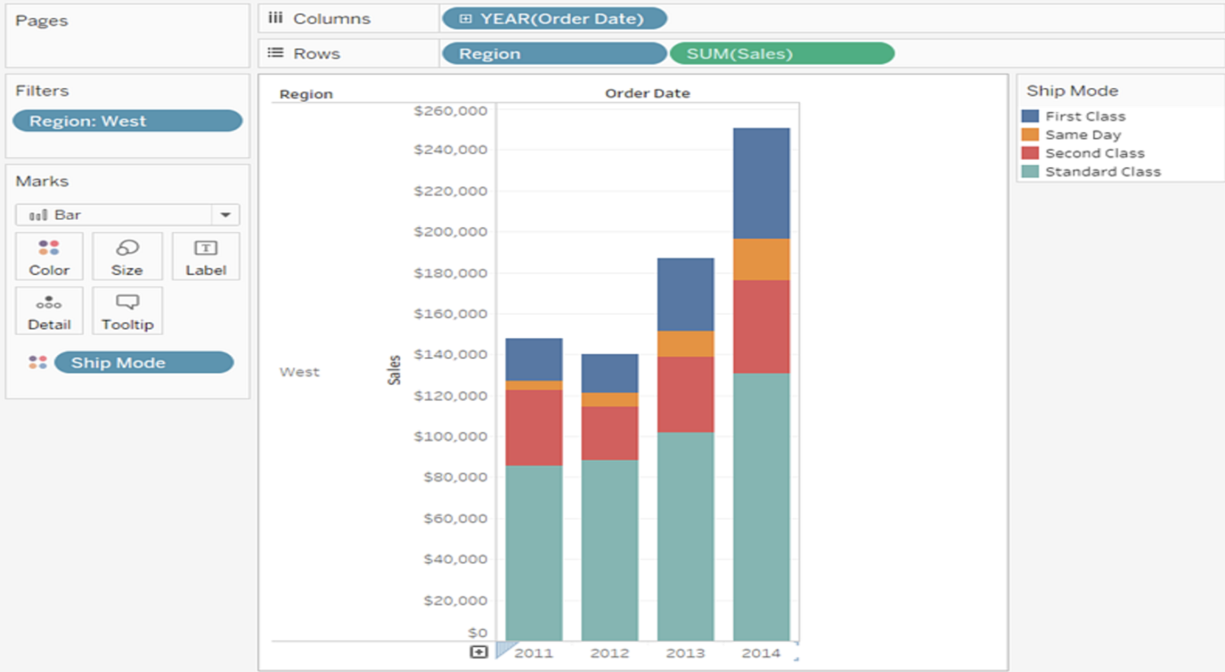

**Step1:** First, go to the worksheet and,

**Step2:** Drag the **Category** field into the column shelf.

**Step3:** Drag **Profit** field into the row shelf.

**Step4:** By default, it creates the **bar chart**.

## Stacked Bar Chart

You can also add one more dimension to the above bar chart to produce a stacked bar chart that shows different in each bar.

**Step1:** Drag the **Segment** field.

**Step2:** And drop the **Segment** field into pane.

## Tableau Line Chart

A line Chart can compare the data over different periods. A series of dots create a line chart. These dots represent the measured values in each period.

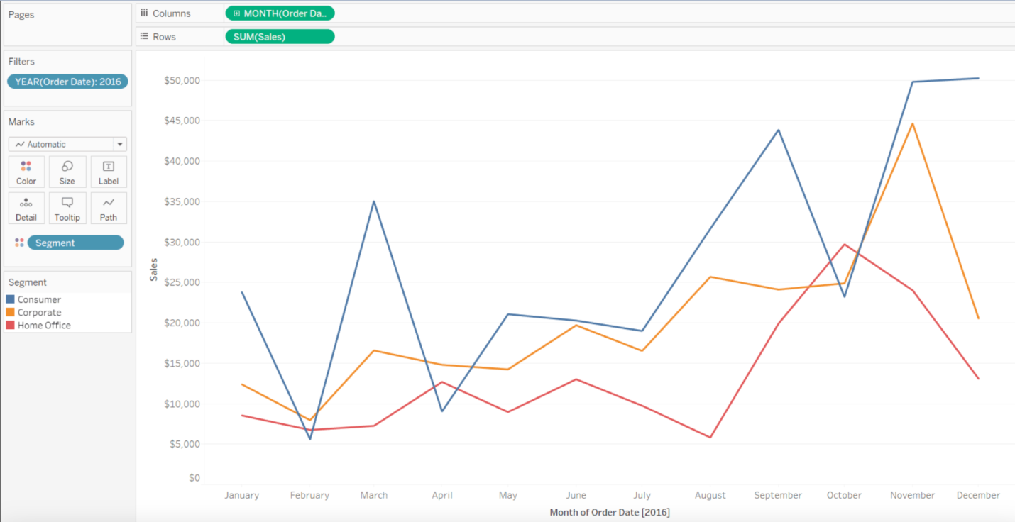

**Step1:** Select one dimension and one measure to create a simple line chart.

**1**) Drag the dimension **Order Date** into Columns Shelf.

**2**) And **Sales** into the Rows shelf.

**3**) It creates the line chart by default or Chooses the Line chart from the "**Show Me**" button.

You will view the following line chart that shows the variation of **Sales** for different **Order Date**

## Multiple Measure Line Chart

## You can use one dimension with two or more measures in a single line chart. It produces various line charts in one pane. Each pane represents the variation between a dimension and the measures.

**Step1:** Drag the dimension **Order Date** into Columns Shelf.

**Step2:** Drag measures **Sales** and **Discount** into the Rows shelf.

## Line Chart with Label

Each of the points that creates the line chart are labelled to make the values of the measure visible.

**Step1:** Drop another measure **Profit** ratio into the "**Labels**" pane in the "**Marks**" card.

**Step2:** Choose average as the aggregation, and you will view the below chart showing the labels.

## Tableau Pie Chart

The pie chart shows the segment-wise data. It can show the contribution of measures over different members in a dimension. The angle of pie determines the measured value. Different colours can be assigned to pie to represent the members in a dimension.

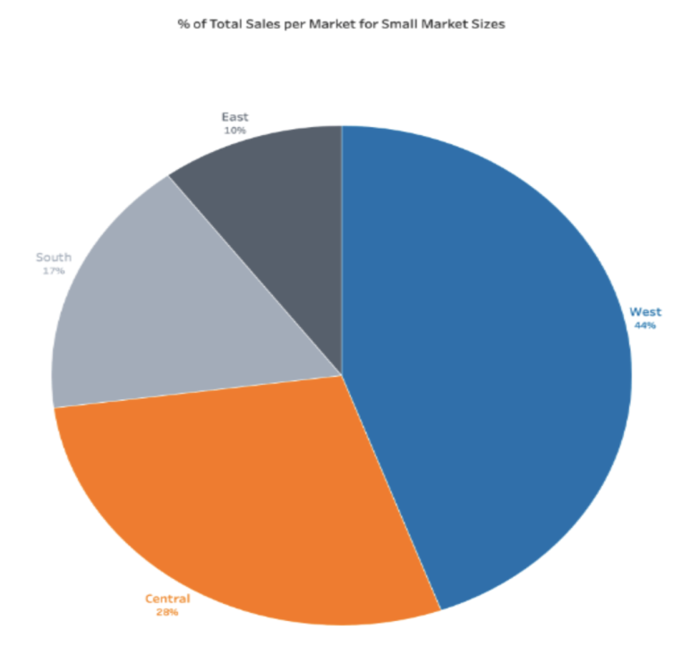

**Step1:** Go to the worksheet.

**Step2:** Drag the dimension **Segment** and drop into the **Color** and **Label** pane.

**Step3:** Drag the measured **Profit** and drop into the **Size** pane.

**Step4:** Choose the chart type from "**Show Me**" pane.

**Show Tree Map and Dual Axis chart.**

The dual axis chart is used to visualize two different measures in two different chart types. A date column and two measures are necessary to build a dual axis chart. **Show Tree Map and Dual Axis chart.**

* Dual axes are useful for two measures with different scales.
* Tree maps display data in nested rectangles. You use dimensions to define the structure of the tree map, and measures to define the size or colour of the individual rectangles.

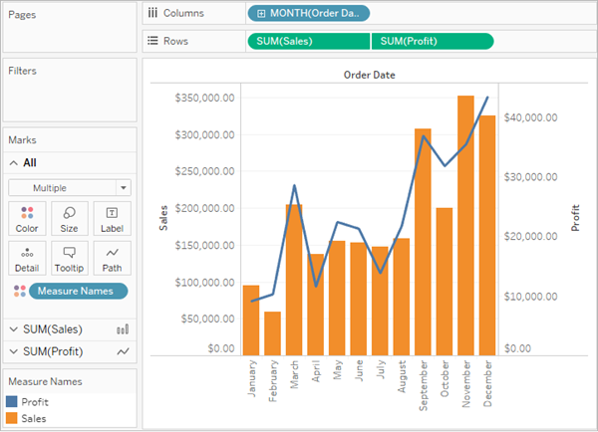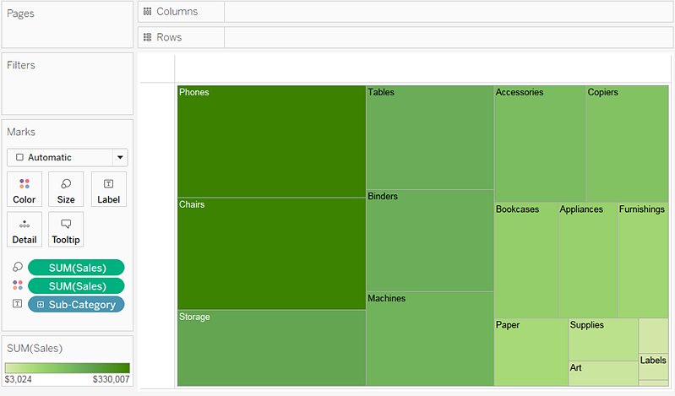

**Dual Axis Chart**

**Tree Map**

**What are text tables and heatmaps?**

* **Text Tables** give us direct information whereas **heat maps** are used to provide better insight from a table at a glance, It is used to enhance the text table.
* The heat map is used to visualize the data in the form of size and colour on different measures.

Two different measures are visualized simultaneously using a heat map. One measure is assigned to size, whereas another measure is attached to the colour of the heat map.

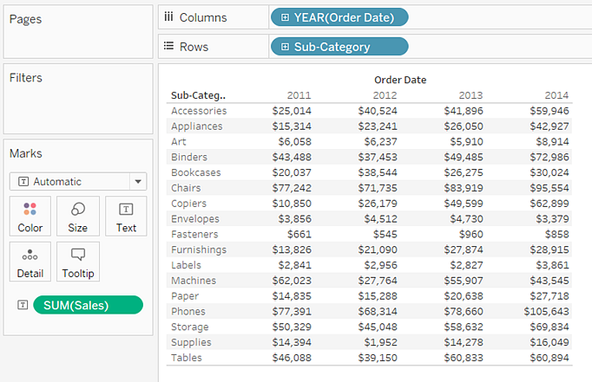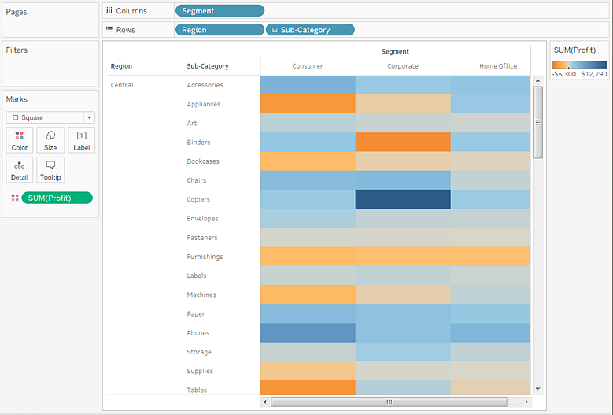

Text Table

Heat Map

**Step 1:** First, go to the worksheet.

**Step 2:** Hold the **Ctrl** key in the keyboard.

**Step 3:** Select the dimension **Sub-Category** and measure **Sales** as shown in the following screenshot.

**Step 4:** Click on the "**show me**" button of the worksheet.

**Step 5:** And select the **Heatmap** icon, as shown in the following screenshot.

**Step6:** Drag measure Profit and drop into the colour shelf under the marks pane

**Step 7:** Drag the dimension **Region** and drop into the column shelf.

## What are the Sets

In Tableau, sets are used to create subsets of data based on the specific condition defined by the user. Sets are only created based on the dimension field.

There are two types of sets in Tableau, such as:

1. **Dynamic Sets:** The values or members in the dynamic sets get change
2. **Fixed Sets:** The values or members in the fixed sets does not change when the underlying data changes.
3. Tableau Sets are **custom fields** that are used to keep a **subset of data** based on a **condition**.
4. you drag a set to the visualization tableau displays the set using the **In/Out mode**. This is a binary categorization of sets
   * In-Members inside the set
   * Out-Members that aren't part of the set
5. There are two types of sets: dynamic sets and fixed sets.
   * The members of a dynamic set change when the underlying data changes. Dynamic sets can only be based on a single dimension.

**What are parameters?**

* While filters limit the data shown in the view, **parameters act as a variable in an equation that can be controlled by the end user.** Parameters only work in conjunction with either filters, sets, reference lines, or calculated fields. Parameters are workbook-wide and can be used in multiple places (i.e. **a single parameter can influence multiple filters and calculated fields across different data sources in the workbook**).
* Creating a parameter to see the change in profit and sales:



* Creating a calculating field and connecting it to our parameter



* Adding Reference Line for each bar



**What is a calculated field and how do use them?**

* Calculated fields allow you to create new data from data that already exists in your data source.
* When you create a calculated field, you are essentially creating a new field (or column) in your data source, the value or members of which are determined by a calculation that you control.



**What is Addressing and Partitioning?**

* The **dimensions that define how to group the calculation** (the scope of data it is performed on) are called **partitioning fields**. The table calculation is performed separately within each partition.
* The **remaining dimensions, upon which the table calculation is performed**, are called **addressing fields** and determine the direction of the calculation.

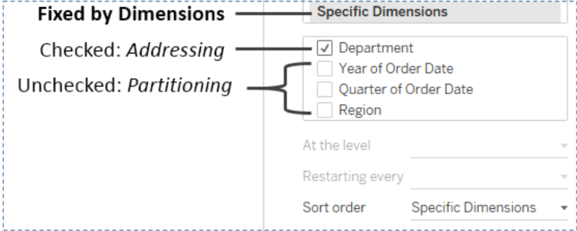

**What is Tooltip:**

* Tooltips are additional data details that display when you hover over one or more marks in the view.
* Tooltip command button for exploring data-
  + Keep only- creates a filter that removes all the other data
  + Exclude- creates a filter that removes the selected data
  + Group members - creates a group based on the selection
  + Create set- creating a new set containing the selected members
  + View data- opens a window displaying the data.

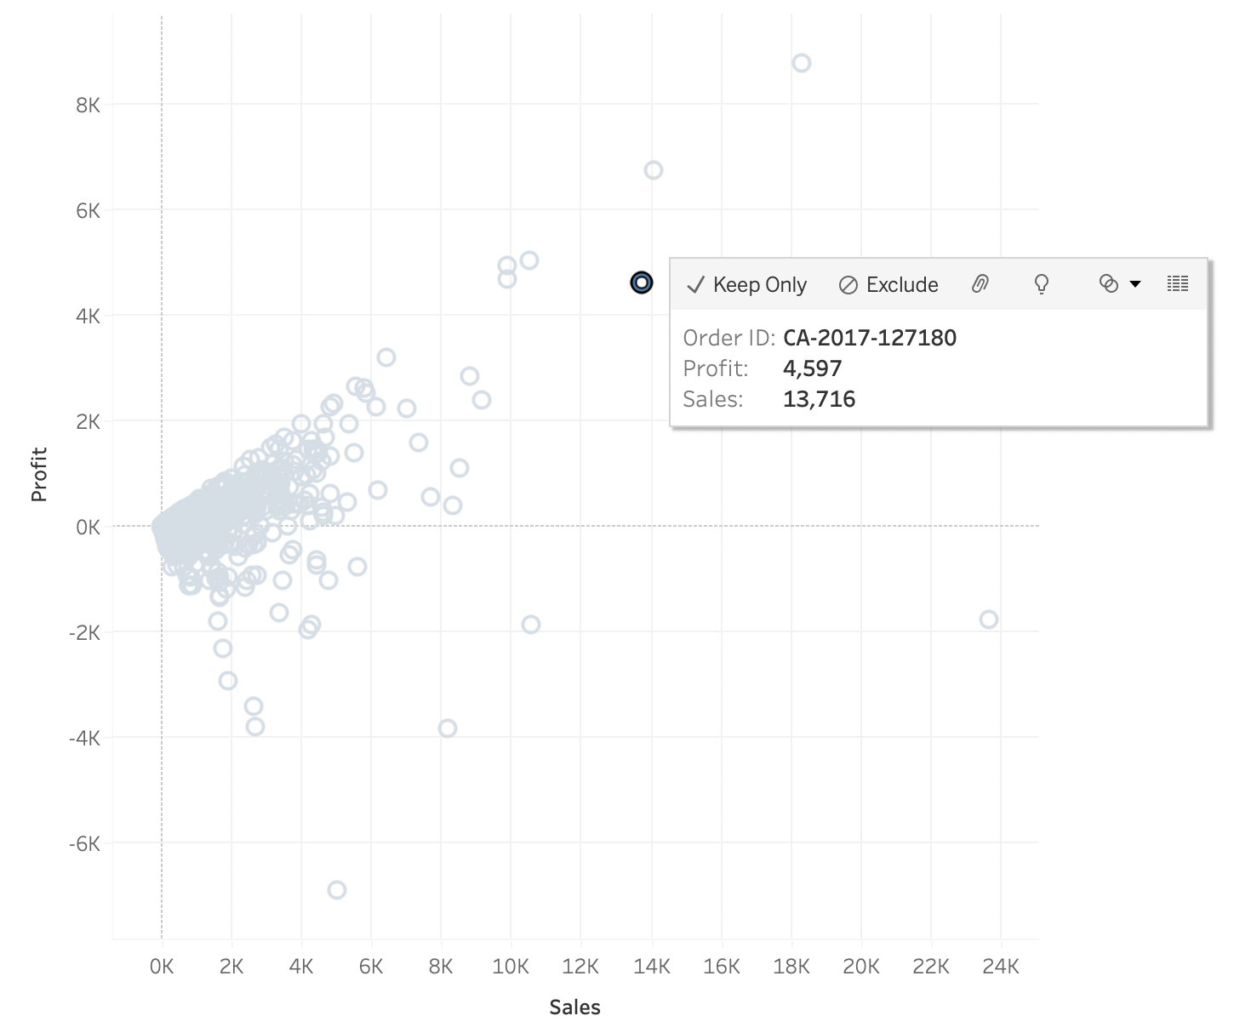

## 

**What is a reference line?**

* You can add a reference line to identify a specific value, region, or range **on a continuous axis** in a Tableau view.
* For example, if you are the monthly sales for several products, you can include a reference line at the average sales mark so you can see how each product performed against the average.
* Tableau lets you add as many reference lines, bands, distributions, and box plots to a view as you require.
* You can add a reference line at a constant or computed value on the axis.
* Computed values can be based on a specified field. You can also include confidence intervals with a reference line.

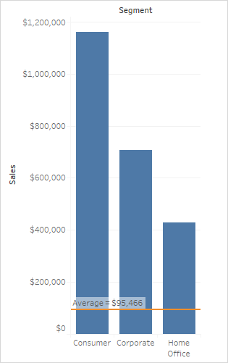

**To add a reference line:**

* Drag the Reference Line from the Analytics pane into the view.
* Tableau shows the possible destinations. The range of choices varies depending on the type of item and the current view.

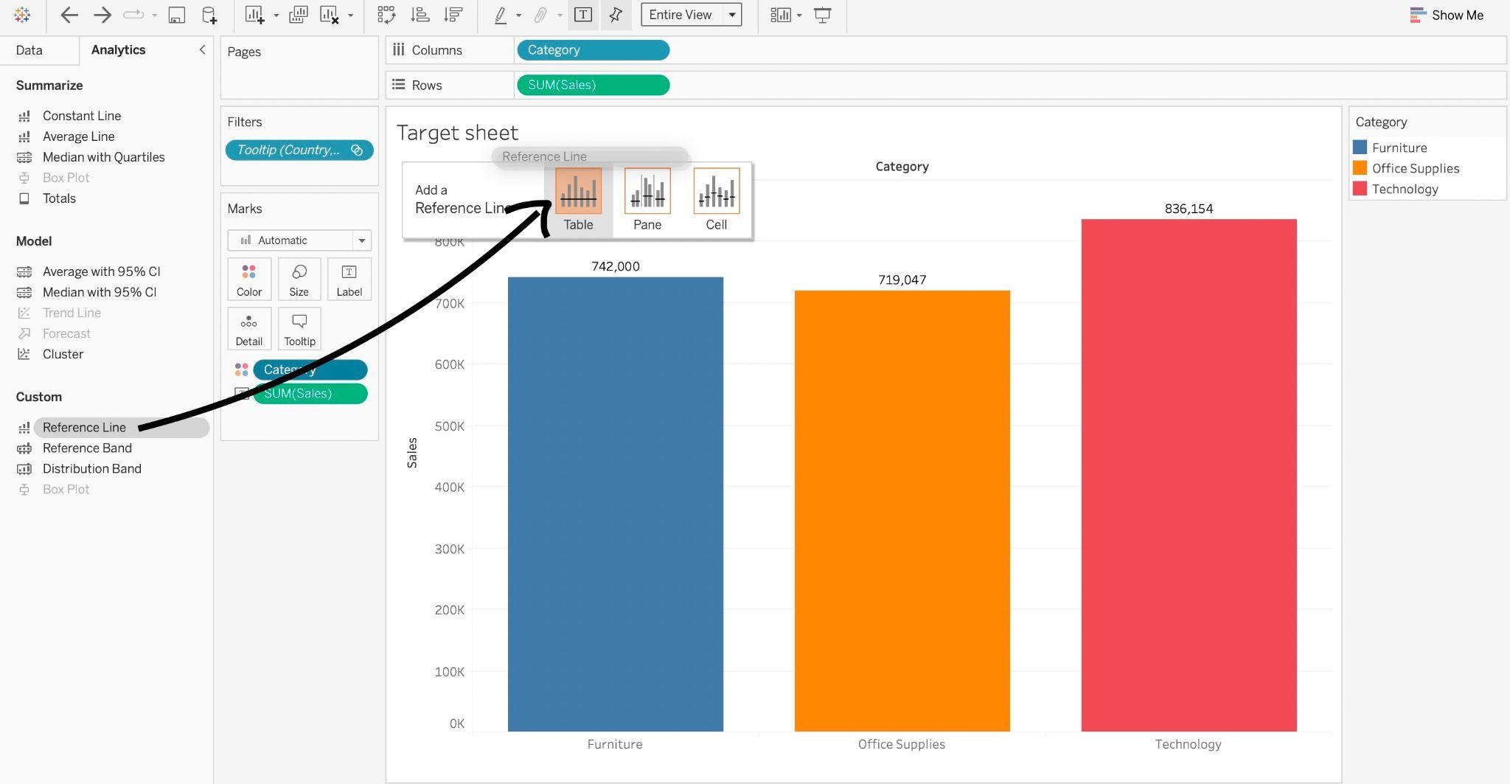

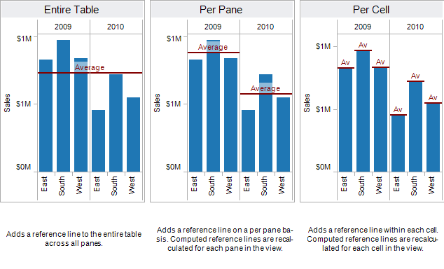

**What are trend lines?**

* Trend lines are used to predict the continuation of a certain trend of a variable.
* It also helps to identify the correlation between two variables by observing the trend in both of them simultaneously.
* Tableau requires a time dimension and a measure field to create a Trend Line.
* To add a trend line to a visualization:
  + Select the Analytics pane.
  + From the Analytics pane, drag Trend Line into the view, and then drop it on the Linear, Logarithmic, Exponential, Polynomial, or Power model types.

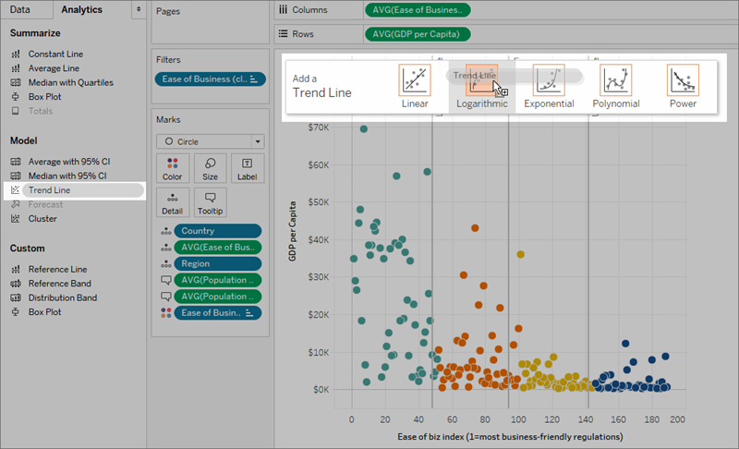

**How to create Maps in Tableau and when to use maps?**

* If you want to analyze your data geographically, you can plot your data on a map in Tableau.
* There are many reasons to put your data on a map. Perhaps you have some location data in your data source or maybe you think a map could really make your data pop
* To build a simple map, your data source must contain location data (for example, location names or latitude and longitude coordinates)
* How to create a map view in tableau
  + Double click any geographical field to build a map view

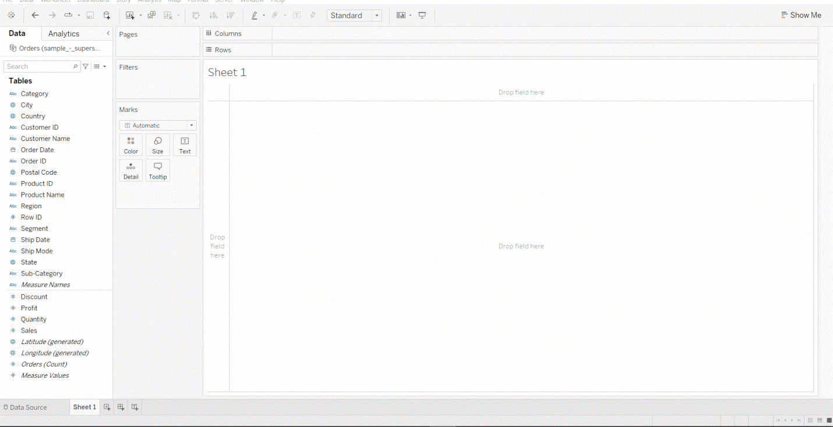

**What is a dashboard in tableau?**

* A dashboard is a collection of several views, letting you compare a variety of data simultaneously.
* For example, if you have a set of views that you review every day, you can create a dashboard that displays all the views at once, rather than navigate to separate worksheets.
* Like worksheets, you access dashboards from tabs at the bottom of a workbook.
* Data in sheets and dashboards is connected; when you modify a sheet, any dashboards containing it change, and vice versa.

**Dashboard interface:**

* A list of worksheets that have not been hidden and which are sorted according to the order in which they are arranged in your workbook
* Containers and objects that can be dragged onto your dashboard to increase the integrity of the design
* A controller for new objects
* A hierarchy of dashboard objects that can be used for navigation
* A controller for the dashboard size
* The canvas where you will compose the dashboard

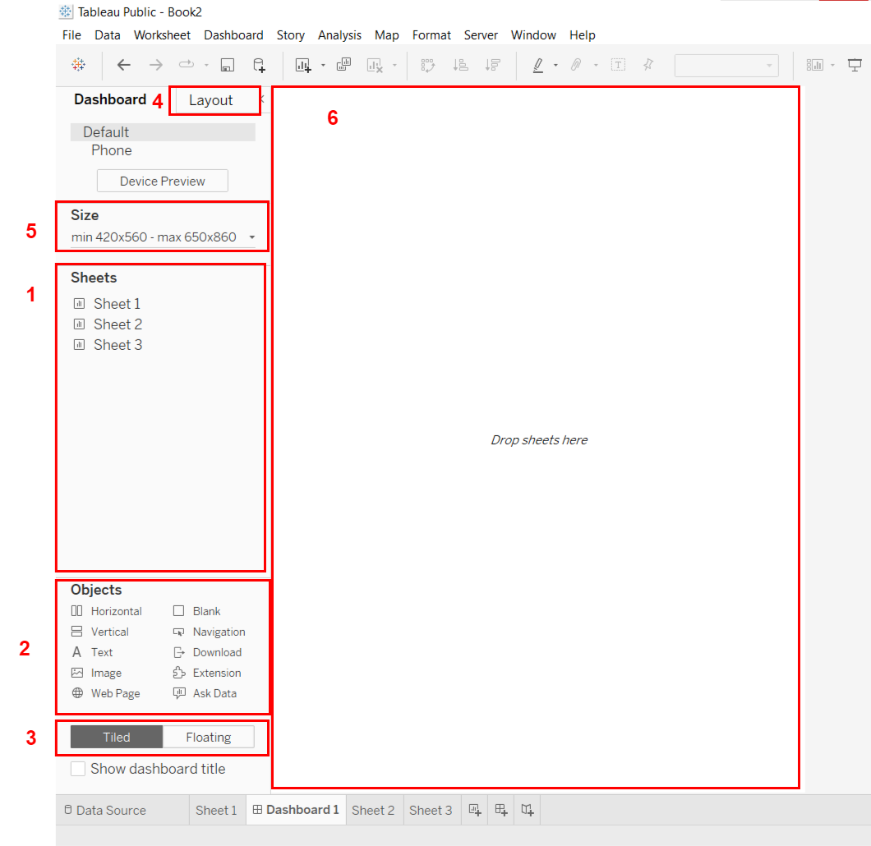

**Creating Dashboard:**

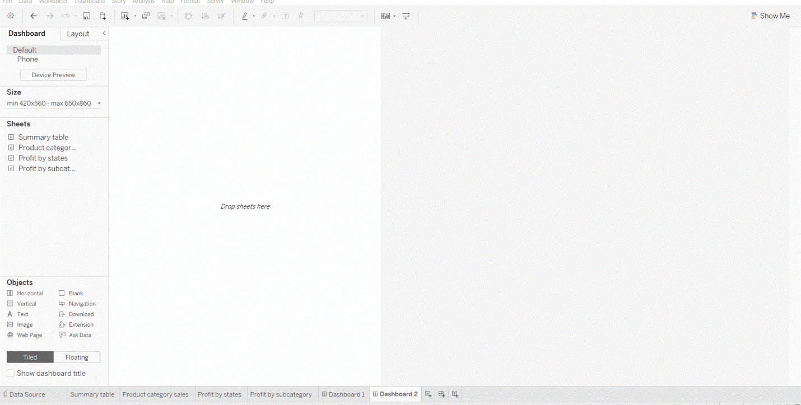

**What is a story in Tableau?**

* In Tableau, a story is a sequence of visualizations that work together to convey information. You can create stories to tell a data narrative, provide context, demonstrate how decisions relate to outcomes, or to simply make a compelling case.

**Story interface on tableau**

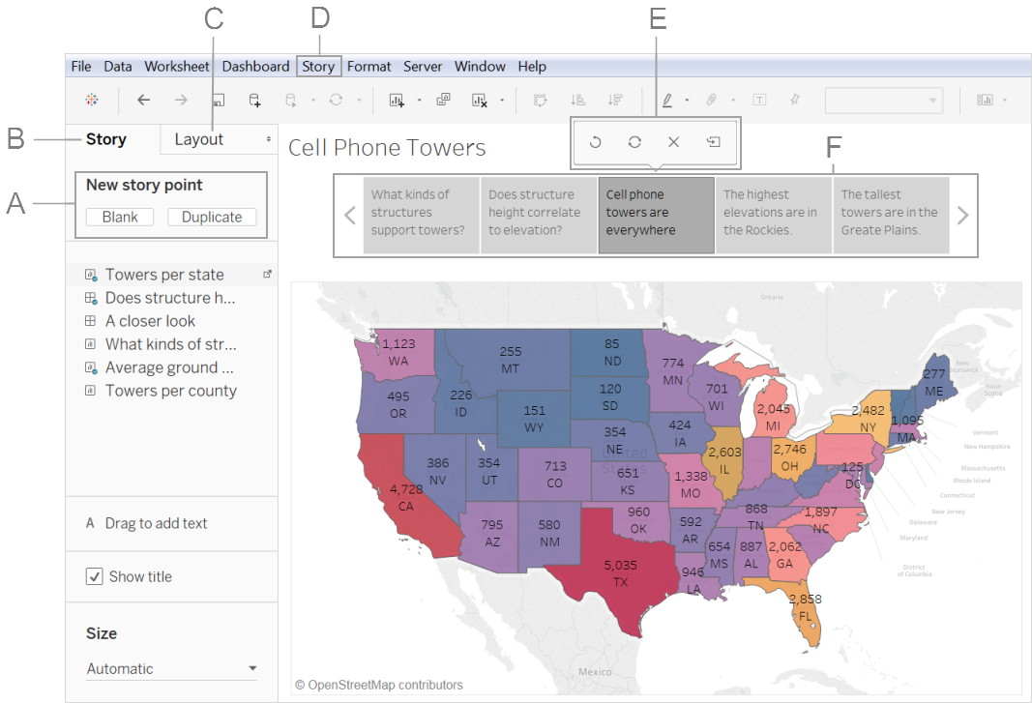

**Creating stories**

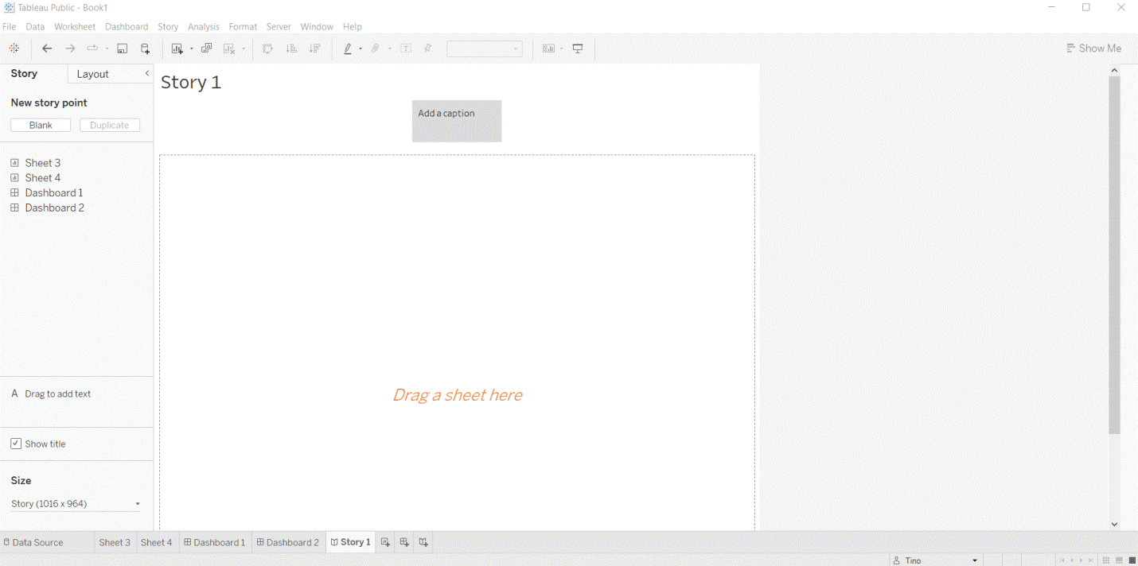

**WORKSHEETS**

A **worksheet** contains a single view along with shelves, cards, legends, and the Data and Analytics panes in its side bar. For details on the worksheet workspace.

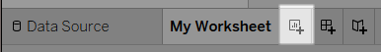

* Select **Worksheet**> **New Worksheet**.
* Right-click any open tab in the workbook, and select **New Worksheet** from the menu.
* On the toolbar, click the drop-down arrow on the **New Worksheet** 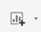 button and then select **New Worksheet**.

**COMBINED SET**

To create a combined set in tableau follow the given instructions:

* Select the sets that want to be combined.
* Right-click on the selected part.
* Click on create combined set.
* Add/modify the values (optional).
* Your combined set is ready.







## 

## FORECAST

To create a forecast, your view must be using at least one date dimension and one measure.

To turn forecasting on, right-click (control-click on Mac) on the visualization and choose **Forecast >Show Forecast**, or choose **Analysis >Forecast >Show Forecast**.

* The field you want to forecast is on the **Rows**shelf and a continuous date field is on the **Columns**shelf.
* The field you want to forecast is on the **Columns**shelf and a continuous date field is on the **Rows**shelf.
* The field you want to forecast on either the **Rows**or **Columns**shelf, and discrete dates are on either the **Rows**or **Columns**shelf. At least one of the included date levels must be Year.
* The field you want to forecast is on the Marks card, and a continuous date or discrete date set is on **Rows**, **Columns**or **Marks**.

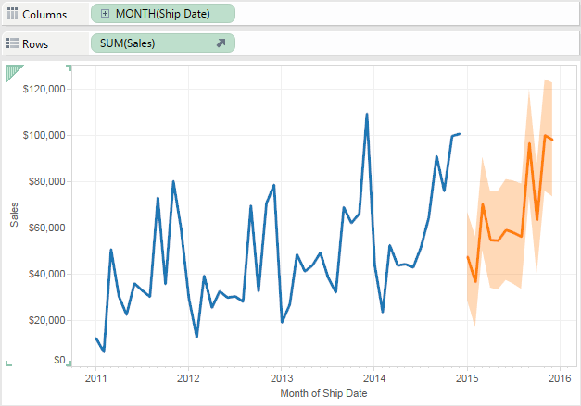

**What is Union in Tableau?**

* **Union**: To combine two or more tables by appending values (rows) from one table to another. To union your data in the Tableau data source, the tables must come from the same connection.

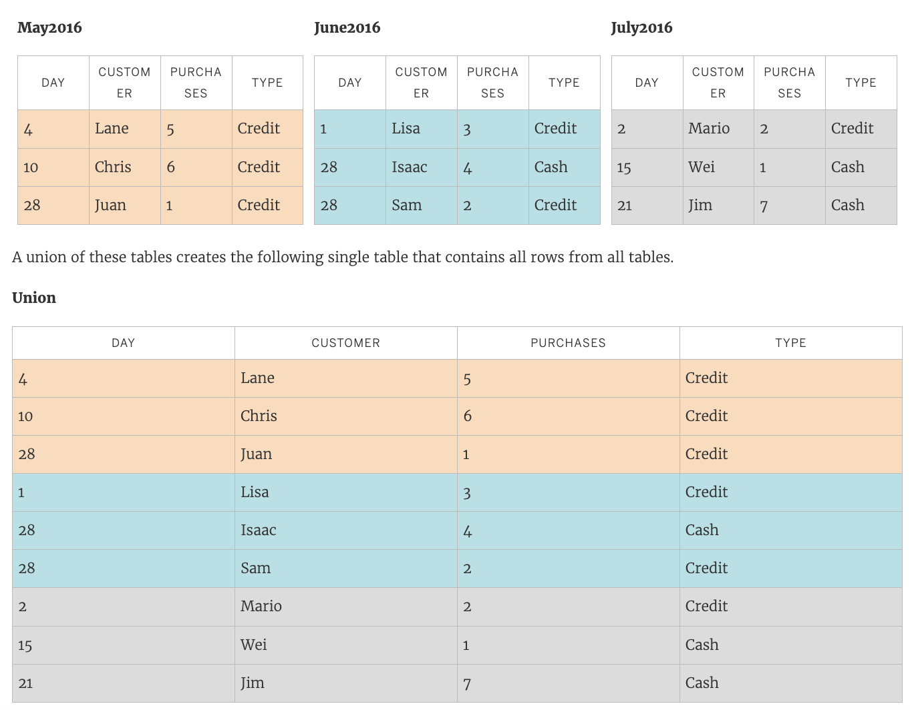

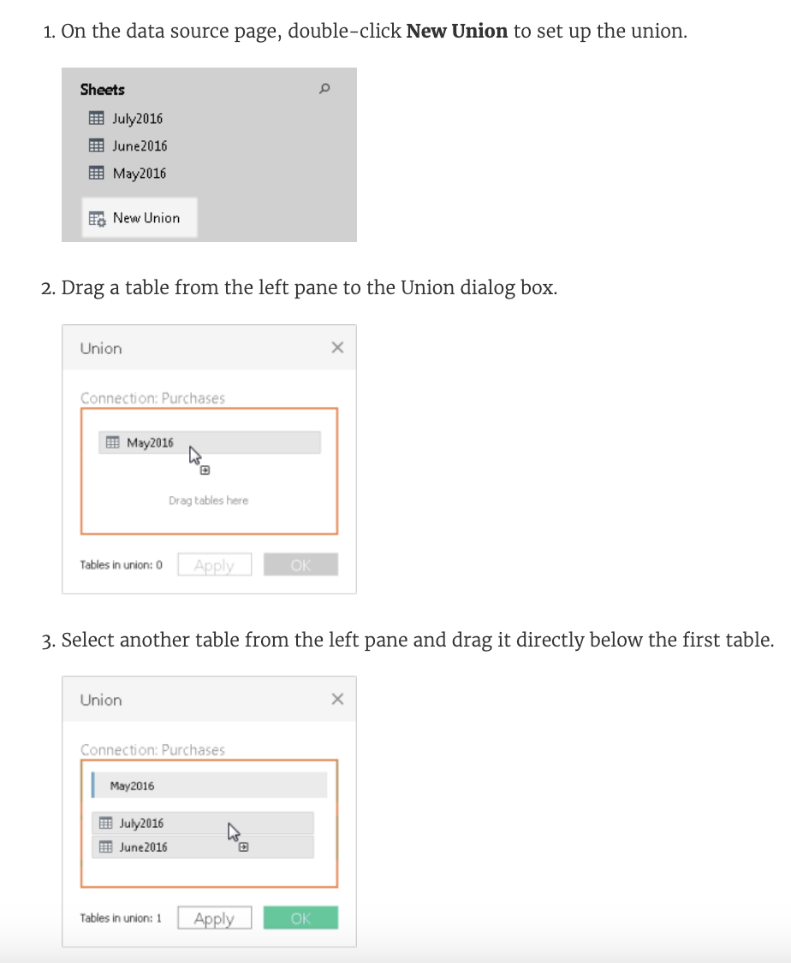

**Dashboard**

The main use of a dashboard is to show a comprehensive overview of data from different sources. Dashboards are useful for monitoring, measuring, and analyzing relevant data in key areas.

## How to Create a Data Dashboard

Before we jump into creating a Tableau dashboard, we need to understand a few rules. These rules will help you build an effective dashboard that will fulfill your target audience's demands and goals.

1. Know your audience and understand what they need.
2. Choose relevant and relatively clean data that will meet your goals.
3. Make sure your data is correct and clean.
4. Select the best visualizations that represent your data.
5. If you are developing a dashboard for the first time, choose a template that reduces complexity and saves time.
6. Do not clutter your dashboard space with too many plots. Use simple colours and allow for space in your design to showcase the most significant parts of the data.
7. Ask for feedback from the audience and use it to improve on the current design. Iterate and improve.

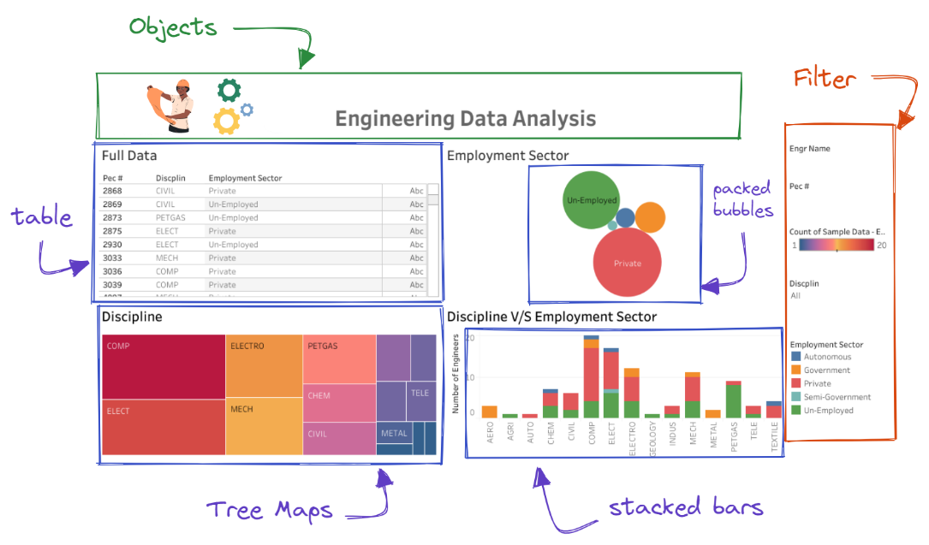

**STORY**

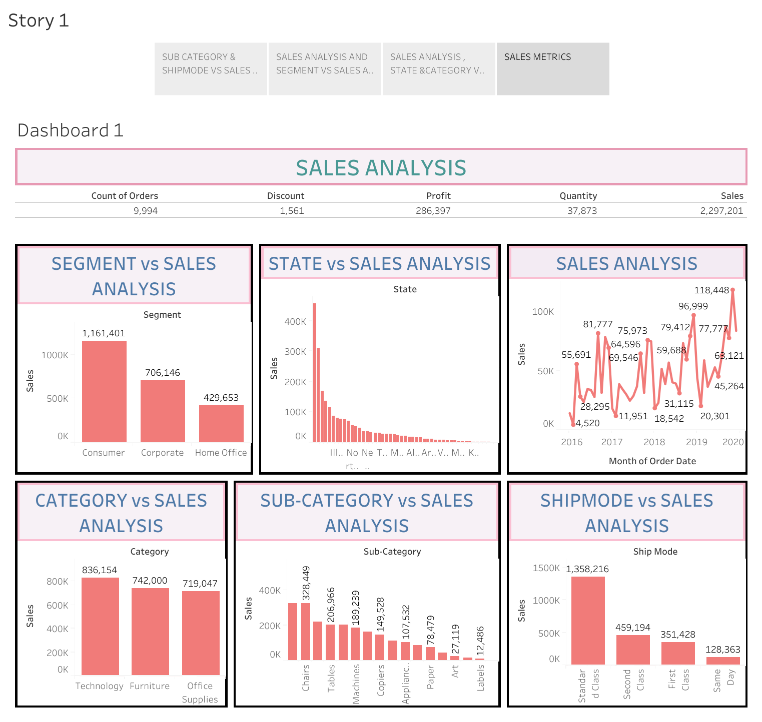

[https://public.tableau.com/views/Story1_17176527604660/Story1?:language=en- US&publish=yes&:sid=&:display_count=n&:origin=viz_share_link](https://public.tableau.com/views/Story1_17176527604660/Story1?:language=en-%20%20%20%20%20%20%20%20%20US&publish=yes&:sid=&:display_count=n&:origin=viz_share_link)

## MINI PROJECT -1

## NETFLIX TITLES

I Analyzing the Netflix titles data and build the dashboard to give insights about following business use cases

Netflix Data Analysis Business Use cases

1.How many titles are there based on the ratings

2.Number of titles by country (count the titles by country wise)

3.Distribution of titles by rating and year

4.No of titles added by month year(like nov 2015)

5.Percentage of total count of titles for top 10 countries

6.Distribution of Movies and TV shows (percentage of total)

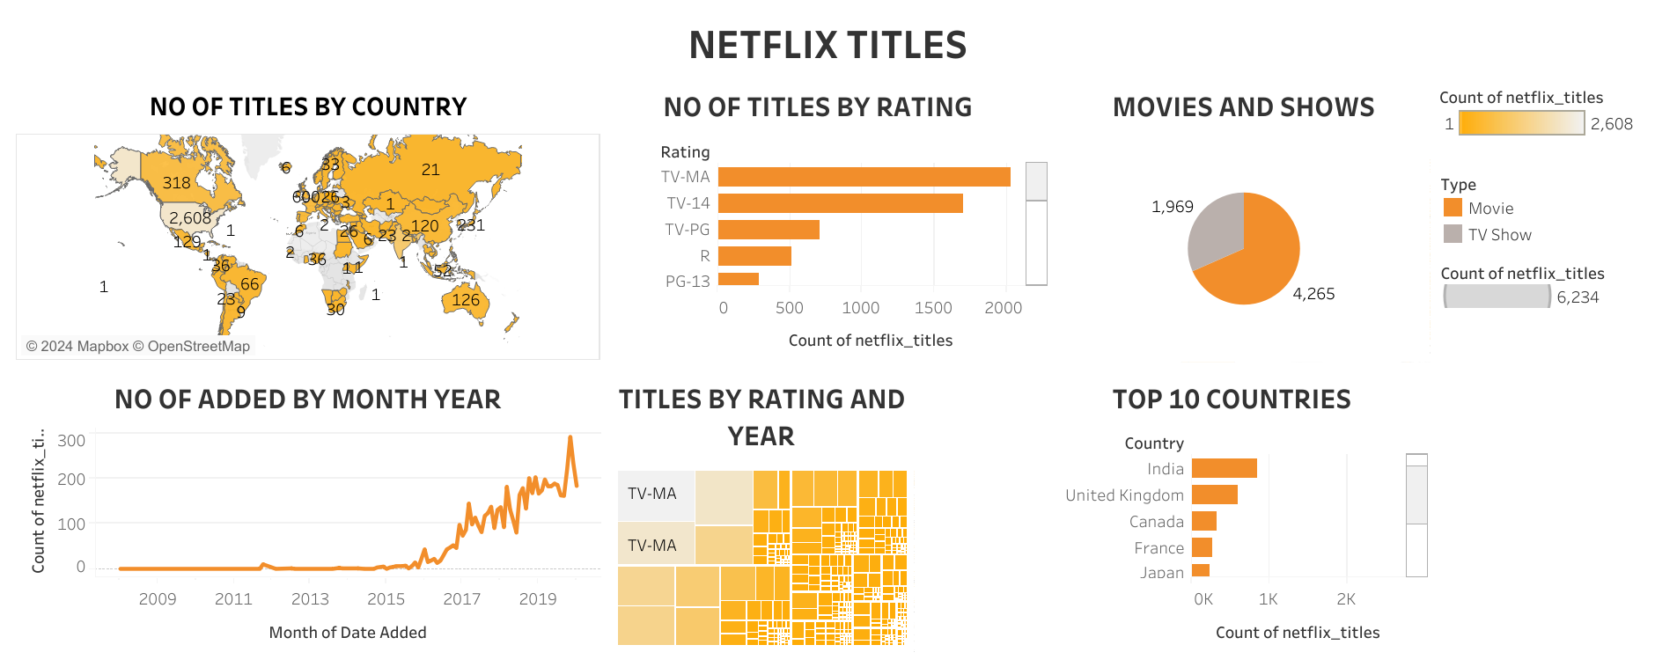

<https://public.tableau.com/views/netflixtitles_17180861389600/Dashboard1?:language=enUS&publish=yes&:sid=&:display_count=n&:origin=viz_share_link>

MINI PROJECT -2

**OMEGA -HR DATA SET**

I Analyzing the OMEGA HR data set and build the dashboard to give insights about the following business use cases

* 1. Header Metrics (No. of Employees, Active Employees, No. of job titles)
  2. Hiring trend vs termination trend
  3. No. of Employees by Department
  4. Gender Distribution
  5. Age Distribution
  6. Top 10 job titles

[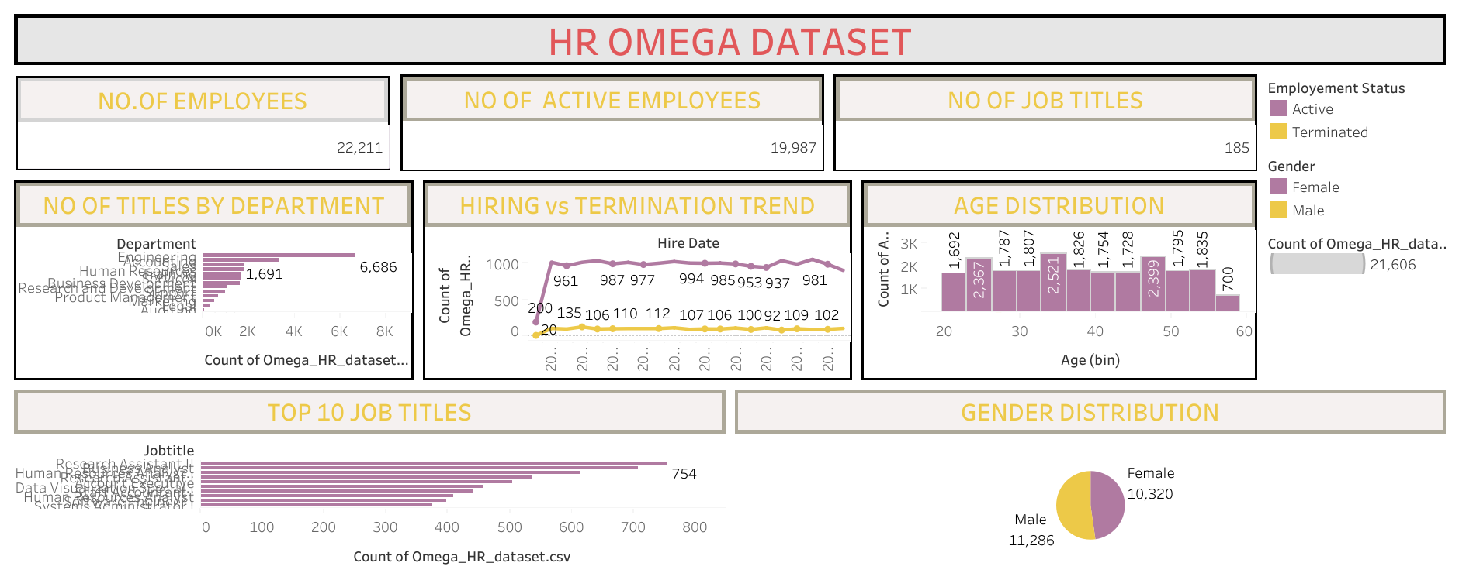](https://public.tableau.com/views/HROMEGADASHBOARD/Dashboard1?:language=en-US&publish=yes&:sid=&:display_count=n&:origin=viz_share_link)

<https://public.tableau.com/views/HROMEGADASHBOARD/Dashboard1?:language=en-US&publish=yes&:sid=&:display_count=n&:origin=viz_share_link>

MINI PROJECT -3

**WINE SALES- RAW DATA**

**Dataset** : -Wine Sales Raw Data All Header metrics in one single chart (Here revenue, unit price, freight expenses are dealing with currencies, so we need to show the dollar symbol before them and display unit to be million ,the unit price should be average, discount to be percentage) Revenue by region and subsegment (Create a heat map) find revenue by first 3 state/province combined, next 3 states/provinces combined and next 2 states combined.(revenue state/province breakdown) Find the top 1 subsegment by revenue( you need to show always top 1 subsegment in separate colour using sets). Now suppose that subsegment X is top 1 it should be coloured differently. Later if subsegment Y is top1 not X it should be coloured differently Find the top 10 customers by revenue (using sets) find top 10 customers by order quantity(using sets) Find the customers that are there in both the sets(find the cream customers or loyal customers)(combine set) (scatter plot)

[https://public.tableau.com/views/Book2_17170483904060/DASHBOARD3?:language=en-US&publish=yes&:sid=&:display_count=n&:origin=viz_share_link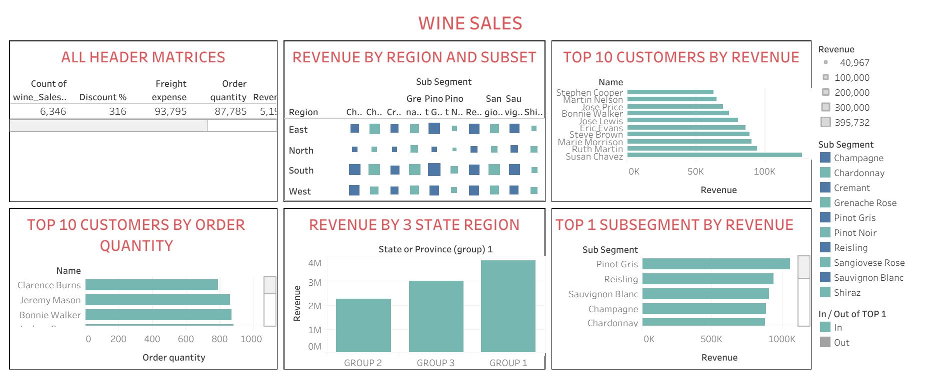](https://public.tableau.com/views/Book2_17170483904060/DASHBOARD3?:language=en-US&publish=yes&:sid=&:display_count=n&:origin=viz_share_link)

<https://public.tableau.com/views/Book2_17170483904060/DASHBOARD3?:language=en-US&publish=yes&:sid=&:display_count=n&:origin=viz_share_link>

**MINI PROJECT -4**

**SUPER STORE INSIGHTS**

I Analyzing the data in sample Super Store and build a dashboard to give insights about following business use cases

* 1. How many subcategories are not met sales target of $75,000
  2. In one chart do the sales vs Profit analysis by product Name and by Customer Name
  3. Distribution by sales (tree map)
  4. See the Sales and profit given month year in one chart (combined chart) and forecast
  5. Dual Axis chart

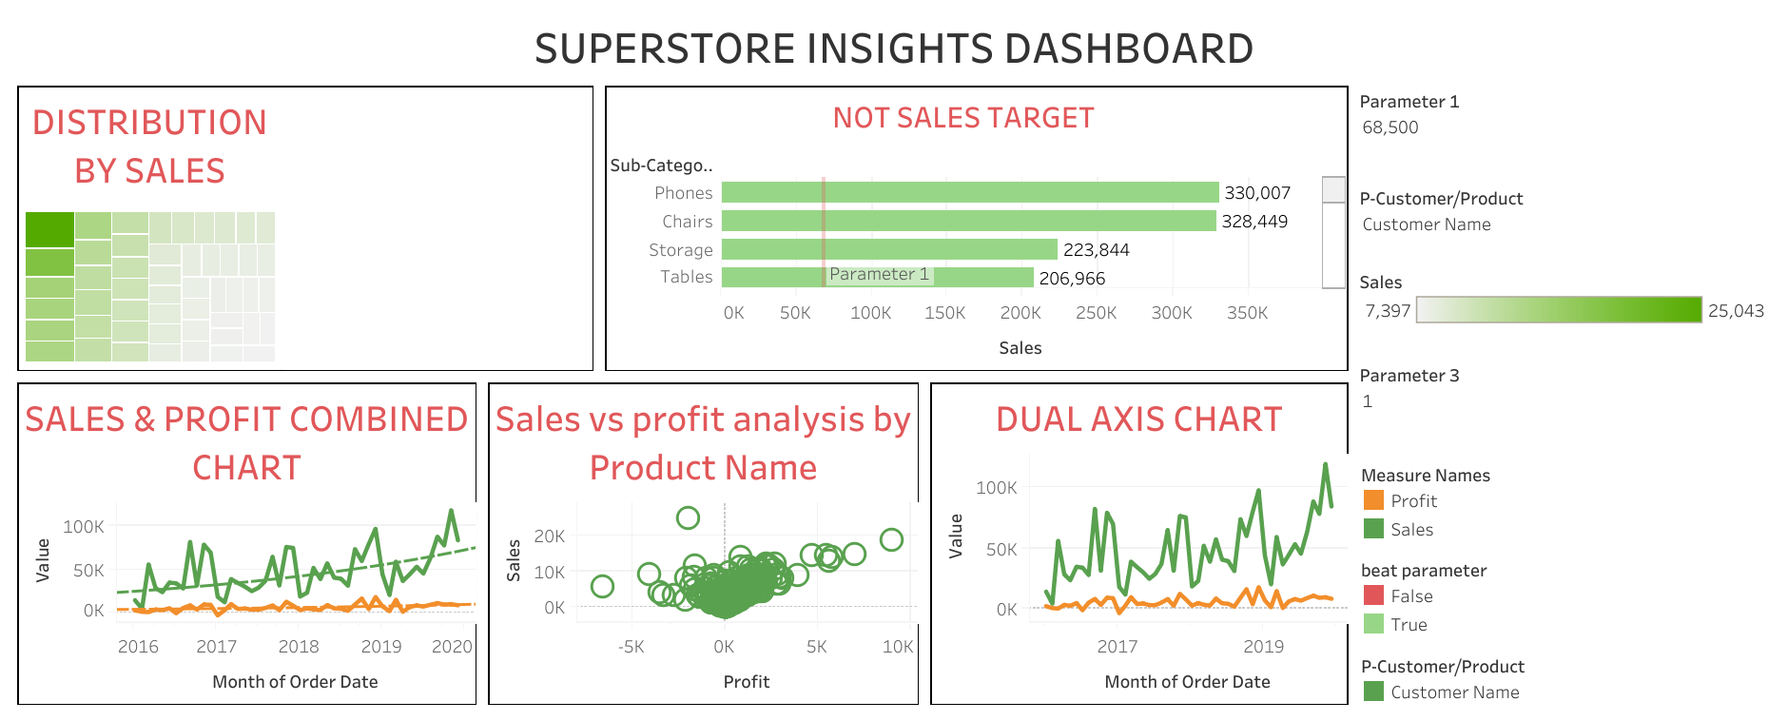

<https://public.tableau.com/views/superstoreinsightsdashboard_17171369455570/Dashboard1?:language=en-US&:sid=&:display_count=n&:origin=viz_share_link>

**MAIN PROJECT**

**SUPER STORE INTERACTIVE DASHBOARD**

Consider the sample store dataset and create a dashboard that will give sales metric, sales analysis, category X Sales analysis, subcategory X Sales analysis, Segment X Sales analysis, Ship mode X Sales analysis, State X Sales analysis. Similarly create the like kind dashboard for Profit and Quantity. with these 3 dashboards

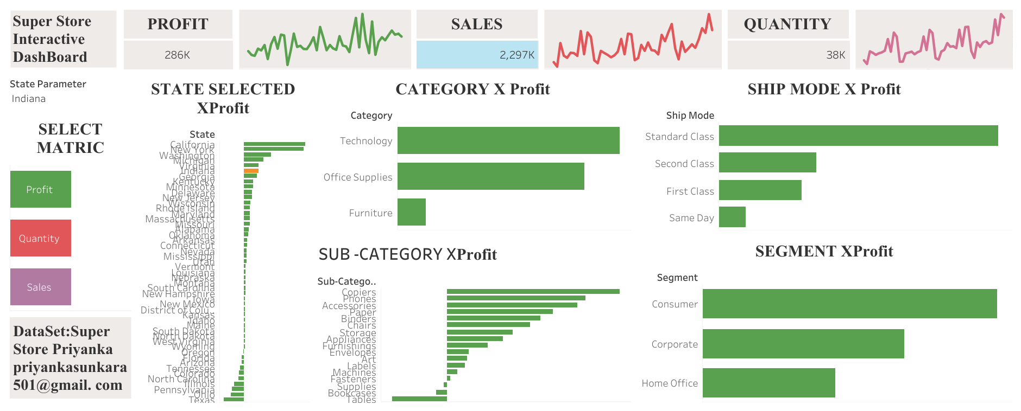

<https://public.tableau.com/shared/PQCSJK45S?:display_count=n&:origin=viz_share_link>